**D205 DATA ACQUISITION TIP SHEET**

*D205 is a fun course based on the SQL programming language using Postgres (PostgreSQL). The course has nine chapters and a Performance Assessment. Most of the chapters have flashcards and labs. Only the first six chapters are required for study. Chapters seven through nine are optional study.*

# **SQL for Data Acquisition**

**The nine chapters only the first six are necessary for study.**

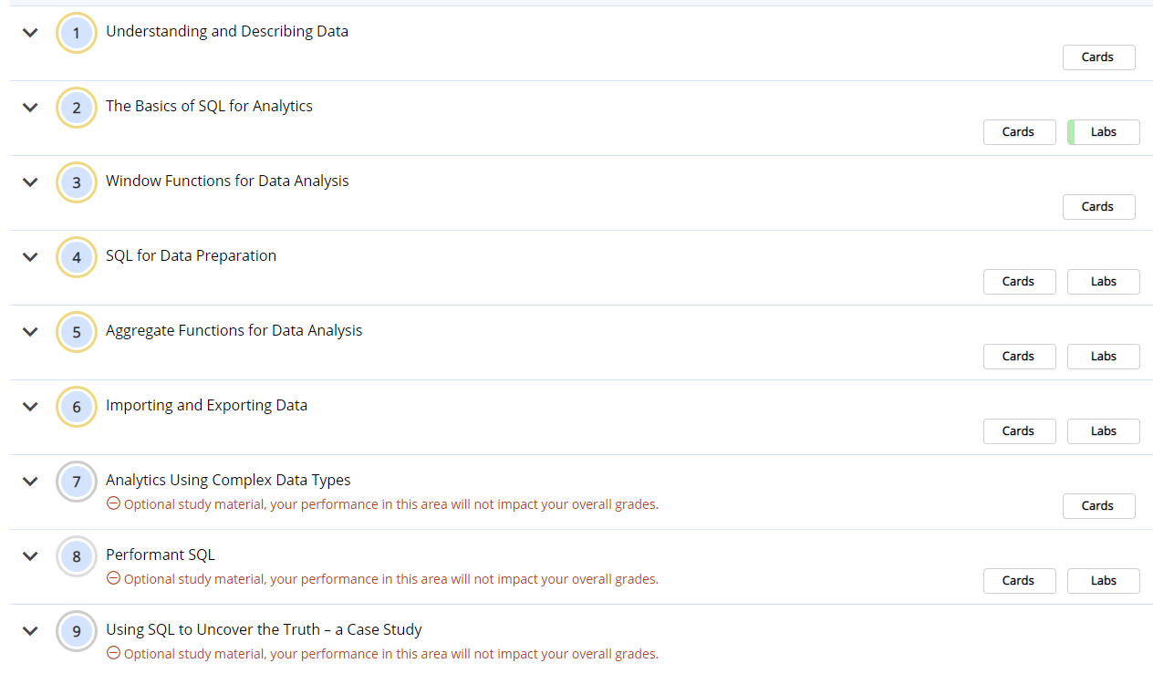

**Use the highlighted grid to navigate between lessons and labs.**

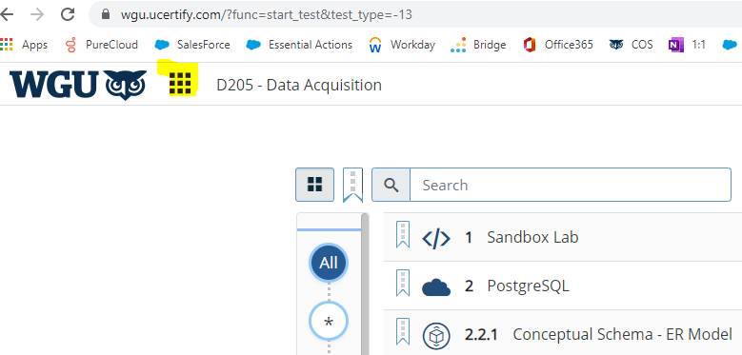

**Click the highlighted grid in this graphic to display labs in a grid view.**

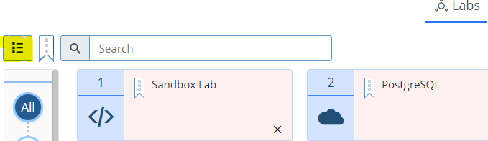

**You have at least four different ways to work in SQL for this course. Here they are:**

1. Use the labs and the Postgres environment in the lessons.
2. Download and install Postgres from here https://www.postgresql.org/download/windows/

and use pgAdmin 4, a GUI tool installed with Postgres.

1. Use psql from the command line.
2. Use db-fiddle.com a stateless tool, that requires no downloading, installation nor configuration.

## Learning Resources

**Attend and follow SQL Sunday Webinars and PowerPoints.**

**Now, here are the SQL Sunday recordings.  These are performed on db-fiddle.com for MySQL but the same code runs fine if you set the compatibility level to Postgres 12.**

**Join me for SQL Sunday live!  The invitation is on the second slide of the PowerPoint presentations.**

Here are all the SQL Sunday Webinars and PowerPoints to date:

|  |  |  |  |  |  |  |  |  |  |  |  |  |  |  |  |  |  |
| --- | --- | --- | --- | --- | --- | --- | --- | --- | --- | --- | --- | --- | --- | --- | --- | --- | --- |
| **SQL Sunday August 2020 Monthly Webinar recording:** | | | | | |  |  |  |  |  |  |  |  |  |  |  |  |
| https://wgu.hosted.panopto.com/Panopto/Pages/Viewer.aspx?id=092986ae-87e2-4725-bd60-ac200187c1b6 | | | | | | | | | | |  |  |  |  |  |  |  |
|  |  |  |  |  |  |  |  |  |  |  |  |  |  |  |  |  |  |
| **August SQL Sunday Powerpoint covering INNER, OUTER, and CROSS JOINs:** | | | | | | | |  |  |  |  |  |  |  |  |  |  |
| https://westerngovernorsuniversity-my.sharepoint.com/:p:/g/personal/william_sewell_wgu_edu/EZPJhE4sYf5Gls7Rq6vfgFIBr6H4AgdU0vsL_I34eaqMqg?e=ij4yQF | | | | | | | | | | | | | | | |  |  |
|  |  |  |  |  |  |  |  |  |  |  |  |  |  |  |  |  |  |
| **SQL Sunday September 2020 Monthly Webinar recording:** | | | | | |  |  |  |  |  |  |  |  |  |  |  |  |
| https://wgu.hosted.panopto.com/Panopto/Pages/Viewer.aspx?id=7dcc6ff9-bef0-4966-8cce-ac43015f7faf | | | | | | | | | | |  |  |  |  |  |  |  |
| **September 6th Presentation covering Unions, Views, and Comments:** | | | | | | | |  |  |  |  |  |  |  |  |  |  |
| https://westerngovernorsuniversity-my.sharepoint.com/:p:/g/personal/william_sewell_wgu_edu/Eb6Z-5m1445Hn4vwjVvEeKQB3J23y3G218Jb1KbEi6zWQA?e=lKbBR0 | | | | | | | | | | | | | | | | |  |
| **September 13th Presentation covering Users, Roles, and Privileges:** | | | | | | |  |  |  |  |  |  |  |  |  |  |  |
| https://westerngovernorsuniversity-my.sharepoint.com/:p:/g/personal/william_sewell_wgu_edu/Ec7XQTfNq89Bm5ozEsFeKYIB5No2-SrijrSdChHLw3BU0g?e=x1ycfv | | | | | | | | | | | | | | | |  |  |
| **September 20th Presentation covering CASE statements and JOINs:** | | | | | | |  |  |  |  |  |  |  |  |  |  |  |
| https://westerngovernorsuniversity-my.sharepoint.com/:p:/g/personal/william_sewell_wgu_edu/EXOLaw9AYwlEjwa2PVbaBvYBoOMF4nYOLuv29c20nU8Fmg?e=otPqN9 | | | | | | | | | | | | | | | | |  |
|  |  |  |  |  |  |  |  |  |  |  |  |  |  |  |  |  |  |
| **SQL Sunday October 2020 Monthly recording;** | | | | |  |  |  |  |  |  |  |  |  |  |  |  |  |
| https://wgu.hosted.panopto.com/Panopto/Pages/Viewer.aspx?id=eac2e637-1c6e-469c-84e3-ac5f0154354c | | | | | | | | | | |  |  |  |  |  |  |  |
| **October 4th Presentation covering Round(), Decimal datatype and Stored Procedures:** | | | | | | | | |  |  |  |  |  |  |  |  |  |
| https://westerngovernorsuniversity-my.sharepoint.com/:p:/g/personal/william_sewell_wgu_edu/EcZbtVLPlJtIgHx7qkt8CbkBl5qFFvKVVOr46smpz6T01A?e=b7maWj | | | | | | | | | | | | | | | |  |  |
| **October 11th Presentation covering NULL and Datetime datatypes and Stored Procedures:** | | | | | | | | | |  |  |  |  |  |  |  |  |
| https://westerngovernorsuniversity-my.sharepoint.com/:p:/g/personal/william_sewell_wgu_edu/EcnFpEd9pUlOjmElr_jMpsMBbFDW_OdsuZ8Qm1E3SUpk9g?e=NHiUfG | | | | | | | | | | | | | | | | |  |
| **October 18th Presentation covering Truncate, Delete, and Functions:** | | | | | | | |  |  |  |  |  |  |  |  |  |  |
| https://westerngovernorsuniversity-my.sharepoint.com/:p:/g/personal/william_sewell_wgu_edu/EehnEryQmaRIvbTL21_etR4BE_8UQ1X1DLLbz0hz66slrA?e=duDLhx | | | | | | | | | | | | | | | |  |  |
|  |  |  |  |  |  |  |  |  |  |  |  |  |  |  |  |  |  |
| **SQL Sunday November 2020 Monthly recording:** | | | | |  |  |  |  |  |  |  |  |  |  |  |  |  |
| https://wgu.hosted.panopto.com/Panopto/Pages/Viewer.aspx?id=576f6120-49b8-4d96-ab5b-ac7c000b3bf0 | | | | | | | | | | |  |  |  |  |  |  |  |
| **November 1st Presentation covers Triggers, Markups, Group By:** | | | | | | |  |  |  |  |  |  |  |  |  |  |  |
| https://westerngovernorsuniversity-my.sharepoint.com/:p:/g/personal/william_sewell_wgu_edu/EWWZ8DX8S-pBhjlO_xHtTzYBoyyj4YykPEym51xlBqi2wQ?e=3PZkcC | | | | | | | | | | | | | | | | |  |
| **November 8th Presentation covering Functions, Associative Entities, Group By:** | | | | | | | | |  |  |  |  |  |  |  |  |  |
| https://westerngovernorsuniversity-my.sharepoint.com/:p:/g/personal/william_sewell_wgu_edu/EbGZ4elwxhlIq-b-sXJMLsQBOhayPl1yXCA-I9wo3J7uUw?e=ztPCVq | | | | | | | | | | | | | | | |  |  |
| **November 15th Presentation covers INNER, OUTER, NATURAL JOINS, USING clause, INNER, and subqueries:** | | | | | | | | | | | |  |  |  |  |  |  |
| https://westerngovernorsuniversity-my.sharepoint.com/:p:/g/personal/william_sewell_wgu_edu/EYc8Cnq8pvNLq8pWTWjViR8BeqXM3t1mFW82bw26kq9Oyw?e=xhQEZH | | | | | | | | | | | | | | | | |  |
|  |  |  |  |  |  |  |  |  |  |  |  |  |  |  |  |  |  |
|  |  |  |  |  |  |  |  |  |  |  |  |  |  |  |  |  |  |

## D205 Take 5 Videos

Installing Postgres on Windows

Using PgAdmin for Postgres

Using Psql for Postgres

Table Joins in Postgres

## **Learning Resources**



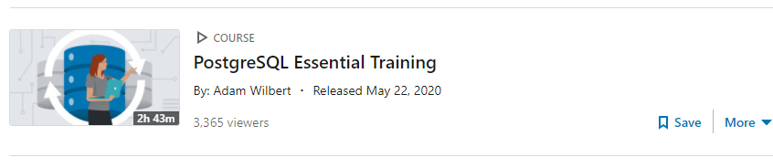

Video link here: Postgres Introduction

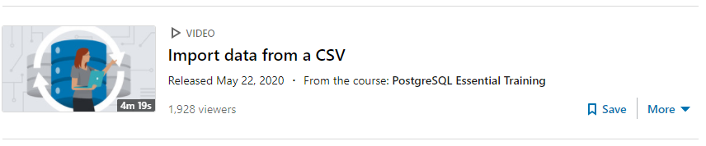

Video link: Using Exercise files

While you are in LinkedInLearning, here are two more Postgres videos:

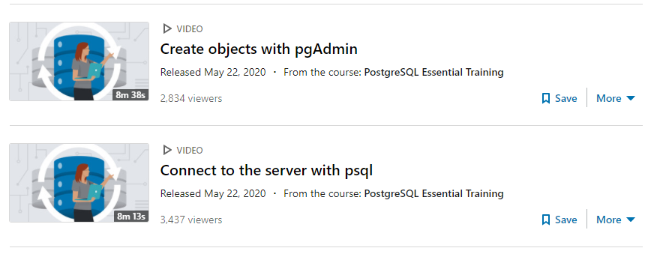

**Students are finding the following very helpful**

# **Other Videos!**

Free Video Course in Postgres (four hours):

https://www.youtube.com/watch?v=qw--VYLpxG4

Postgres Installation video:

https://www.youtube.com/watch?v=fZQI7nBu32M

Postgres for Beginners (two hours):

https://www.youtube.com/watch?v=-VO7YjQeG6Y

Postgres Tutorial (43 minutes):

https://www.youtube.com/watch?v=js84deD7pzk

**Dr. William Sewell**

Direct Line: 385.428.5377 Toll Free: 877.435.7948 ext 5377

Course Instructor, IT

Mountain Time Office hours: Sun 3:00 PM – 8:00 PM, Mon 6:30 AM – 3:30 PM, Tue 9:30 AM – 6:30 PM, Wed 9:00 AM – 5:00 PM, Thu 6:30 AM – 3:30 PM  
cmdatabase@wgu.edu  
Toll Free: 1-877-435-7948

Smailto:william.sewell@wgu.edu